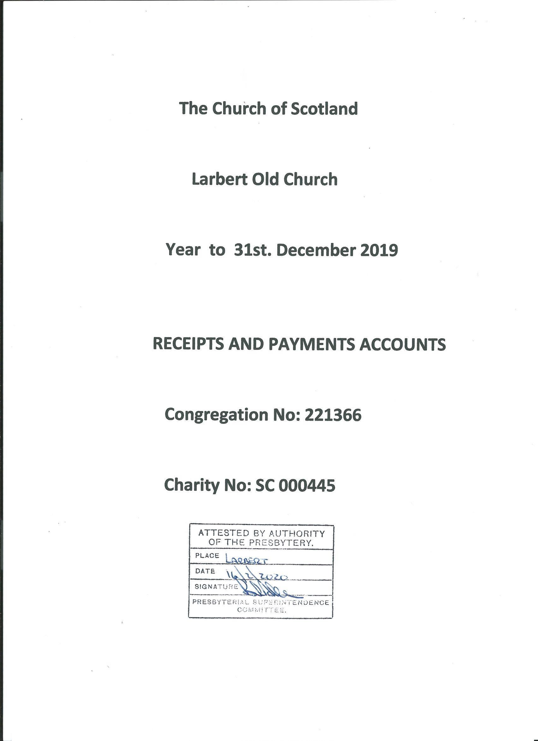

Trustees' Annual Report
The trustees present the annual report and accounts for Larbert Old Church of Scotland for the year ended 31st. December 2019.

Reference and Administrative Information
Charity Name: Larbert Old Church of Scotland
Charity Registration No. SC000445
Congregation Reference No: 221366
Contact Address: 2 Jones Avenue, Larbert, FK5 3ER

KIRK SESSION Trustees who served throughout the year:-
Brian Allan | Janice Drummond
Sallie Allan | Margaret Hall
Ann Allison | Mary Kane
Eric Appelbe | Mary Petrie
Elizabeth Burden | Joseph Sharp
Catherine Cheape | Alistair Simpson
Ronald Cheape | Joy Simpson
Irene Coulthard | Mary Tait
Susan Cunningham | Walter Williamson

Trustees who served part of the year only :-
Iain Scoular from 02.06.2019
Barrie Brown from 06.10.2019
Joanna Stevenson from 06.10.2019
Tom Ferguson to 10.09.2019

Principal Office-bearers
Interim Moderator | Walter Williamson MBE
Session Clerk | Eric Appelbe
Church Treasurer:  Independent Examiner | Alistair Simpson
David Neilson, ACMA  Bank | Willow Dene, Glen Road, Torwood, Larbert FK5 4SN
Clydesdale Bank plc | 31 Hallam Road, Stenhousemuir, Larbert, FK5 3BF
Page 2 of 11
Trustees’ Annual Report - Year ended 31st. December 2019
Structure, Governance and Management

Governing Document
The Church is administered in accordance with the terms of the Unitary Deed of Constitution. Under this structure the single body of the Kirk Session with its constituent committees oversees both civil and ecclesiastical issues, which include everything from property to pastoral care and from finance to vision for the future.

Recruitment and Appointment of Trustees
Members of the Kirk Session are the charity trustees, together with the Locum Minister. The Kirk Session members are the elders of the Church, and are chosen from those members of the congregation who are considered to have the appropriate gifts and skills.
The Interim Moderator, who is a member of the Kirk Session, is appointed by the Presbytery.

Organisational Structure
The Kirk Session, which meets eight times a year chaired by its Moderator, is responsible for spiritual affairs within the church, and, under the Unitary Deed of Constitution, assumes responsibility also for temporal matters previously managed by the Board. Certain responsibilities are delegated to the Session Clerk, to the Treasurer, and to the Property Convenor as appropriate.
The Parent Charity is the Church of Scotland, Charity Reference SC 011353.

Objectives and Activities
The Church of Scotland is Trinitarian in doctrine, Reformed in tradition and Presbyterian in polity. It exists to glorify God and to work for the advancement of Christ's Kingdom throughout the world. As a national church it acknowledges a distinctive call and duty to bring the ordinances of religion to the people in every parish of Scotland through a territorial ministry. It co-operates with other churches in various ecumenical bodies in Scotland and beyond to promote the advancement of religion.
Services are held each Sunday at 11.00 am. During the service there is a creche available: older children leave for Sunday School after the All-age hymn. On the first Sunday of the month there is also a Praise Service at 6.30 pm.
The congregation supports a thriving Boys' Brigade Company, and has links with the Girls' Brigade Company now based at Larbert Baptist Church. It has good relations with Brownies, Guides and Scouts.
The church is associated with the Larbert Mens' Christian Association, and also with the ministry of the Larbert Churches Youth Trust in the High School and its associated Primary schools.
Page 3 of 11

Achievements and Performance
The congregation has continued its centuries old tradition of witness and ministry to the parish of Larbert Old in good heart and with renewed commitment to its responsibility after the demission of its former minister and the departure of some 85 members in 2013.
Our ministry, under the direction of our Interim Moderator, Walter Williamson, was led throughout the year by Iain Scoular, a Reader in the Church of Scotland.
Around 80 persons attend service each week, with larger numbers for special services; many of the congregation join together after service for tea and coffee in the Hall.
The Pastoral Group continues to develop its ministry among those who cannot easily attend Sunday worship. Members of the Worship Group are progressing their training towards their aim of being able to provide leadership of Sunday worship, when required.
The Social Committee and the Knit'n'Natter Group have again held a series of events, some separately and some together, comprising Quiz nights, Coffee Mornings, the Spring Gathering and November Christmas Fayre, and this year for the first time an outing to the MacRobert Centre pantomime in December.
Over 200 young persons from the parish and local uniformed organisations attended the Remembrance Sunday parade service in November. The Knit'n'Natter Group's display of over 2,000 knitted poppies again formed part of special decorations for our Remembrance Day service.
There are good links with Larbert Village Primary School with the Locum Minister involved in end of term services at Christmas, Easter, and Harvest thanksgiving held in Larbert Old, or, if in inclement weather, in the School Hall.
The congregation regularly supports Falkirk Foodbank, and other charities in retiring offerings as listed on Page 10.

Financial Review
The principal source of income is freewill offerings from Church members. The giving in 2019 at £67,406 was almost 6% above the 2018 giving, reflecting the congregation's ongoing commitment to our ministry. We give thanks for three legacies totalling £47,858 received from members of the congregation.
The first steps in our Sanctuary Refurbishment programme, the upgrading of the gutters, the treatment of dry rot, and the replacement of the slates on the northside roof cost almost £180,000. This work was funded by grants totalling £15,000 from the Church of Scotland, congregational funds of £115,000, with the balance covered by an interest bearing loan of £50,000 from the General Trustees, repayable in ten six monthly repayments. At the end of 2019 our liability stood at £32,811.
Page 4 of 11
2019 saw the completion of the next steps in our Sanctuary refurbishment programme with the replacement of the church heating system, improved access for disabled persons via a new ramp to the south door, and the installation of an accessible toilet in the north lobby area. This work, costing £61,023, was funded from the Restoration Fund, supported by grants of £8,000 from the Baird Trust Fund and of £5,000 from the Ferguson Bequest Fund.
We also upgraded our audiovisual system in the church with new screens affixed to the gallery , at a total cost of £3,805, and these have been welcomed by the congregation.
Reserves Policy and Statement of Trustees' Responsibilities
At the year end the Church held unrestricted cash funds of £77,798, of which £55,685 is designated for the Restoration Fund, with £8,414 from the 2019 Rental Fund also assigned by the Kirk Session to
Restoration Programme expenditure and loan/interest repayments, leaving £13,700 for normal operation. We continue to assign all rental income from the vacant manse and from the church cottage to the Restoration programme of works.
It is the Trustees’ policy to seek to hold reserves of approximately five months' expenditure, and it remains a major challenge since the split in 2013 to rebuild our balances to that sort of level over future years, and to manage the ongoing Restoration Programme to equip our facility to meet its purpose of ministry and mission to the western end of Larbert and beyond.
The members of the Kirk Session must prepare financial statements which give sufficient detail to enable an appreciation of the transactions of the Church during the financial year.
The members of the Kirk Session are responsible for keeping proper accounting records which, on request, must reflect the financial position of the Church at that time.
This must be done to ensure that the financial statements comply with the Charities and Trustee
Investment (Scotland) Act 2005, the Charities Accounts (Scotland) Regulations 2006 and the Regulations Anent Congregational Finance approved by the General Assembly of the Church of Scotland in 2012. They are also responsible for safeguarding the assets of the Church and must take reasonable steps for the prevention and/or detection of fraud and other irregularities.
This Report was approved by the Trustees on 11th February 2020 and the original copy was signed on their behalf by

Eric Appelbe
Eric Appelbe, Session Clerk Page 5 of 11
Larbert Old Church

Receipts and Payments Account Year ended 31 December 2019
 | Unrestricted | Restricted | Endowment | Total | Total
 | Funds | Funds | Funds
 | 2019 | 2019 | 2019 | 2019 | 2018
Receipts Note | £ | £ | £ | £ | £
Donations 3 | 82,443 | - | - | 82,443 | 78,068
Legacies | 47,858 | - | - | 47,858 | -
Activities for Generating Funds | - | - | - | - | -
Bank & Deposit interest | 365 | - | - | 365 | 388
Investment income | - | - | - | -  - | -
130,666 - - | 130,666 | 78,456
11,547 - - | 11,547 | 10,563
- - | - | -
- - | - | -
- - | - | -
15,336 - - | 15,336 | -
2,701 - - | 2,701 | 7,530
- - | - | -
- - | '- | -
160,250 - - | 160,250 | 96,549
 | -
72 - - | 72 | 82
150,364 - - | 150,364 | 118,693
- - - | - | -
150,436 - - | 150,436 | 118,775
Rental of premises
Sale of assets
Sale of investments
Grants
Receipts from General Trustees
Sanctuary Refurbishment Fund
Interest Free Loan
General Trustees Loan
Total Receipts
Payments 4
Costs of generating funds
Charitable activities Governance costs

Total Payments
Surplus/ Deficit: Receipts against Payments for the year | 9,814 | - | - | 9,814 | - 22,226
Page 6 of 11
Statement of Balances
At 31 December 2019
Unrestricted Restricted Endowment Total Total
Funds Funds Funds
2019 2019 2019 2019 2018
£ £ £
Bank & Deposit Balances
Bank & deposit balances brought forward  Movement in year: | 67,984 | 0 | 0 | 67,984 | 90,209
Deficit/Surplus | 9,815 | 0 | 0 | 9,815 | -22,225

Bank & deposit balances carried forward
77,799
0
0
77,799
67,984
Held in :-
Church of Scotland Investors' Trust Deposit Fund | 68,220
Clydesdale Bank plc | 9,579
77,799
Investments at market value

Assets 0 0 0 0 0
Liabilities
Loan : the Church of Scotland 32,811 0 0 32,811 43,374

The accounts were approved by theTrustees on 11th February 2020 and signed on their behalf by
Original copy signed by
Eric Appelbe Eric Appelbe __________________________________________________ Session Clerk
and by
Alistair Simpson Alistair Simpson ________________________________________________ Treasurer
Page 7 of 11

Notes to the Accounts 1 Trustee Remuneration and Related Party Transactions
During the year 1 trustee, W.Williamson, received reimbursement of expenses incurred totalling £646. No trustee or a person related to a trustee had any personal interest in any contract or transaction entered into by the charity during the year.
 | At 1 January | Receipts | Payments | At 31 December
 | 2019 |  |  | 2019
 |  | £ | £ | £
General Fund  Designated Unrestricted Funds | 8,135 | 94,356 | 89,901 | 12,590
Sunday School | 593 | 0 | 0 | 593
Common Good Fund | 347 | 0 | 0 | 347
Fabric Reserve Fund | 6,266 | 15,336 | 13,188 | 8,414
Restoration Fund | 50,343 | 48,885 | 43,542 | 55,686
Screens Fund | 2,300 | 1,675 | 3,806 | 169
Total funds | 67,984 | 160,252 | 150,437

2 Movements in Funds
77,799
Sunday School Fund: Funds set apart for use in the Sunday School.
Fabric Reserve Fund: Funds set aside by the trustees and/or donors for the maintenance of the Church property
Common Good Fund : Funds set apart for use at the discretion of the Locum Minister
Sanctuary Restoration Fund : Fund set apart specifically for Sanctuary Refurbishment work
Page 8 of 11
 | Unrestricted | Restricted Endowment |  |  |  | Total
 | Funds | Funds Funds |  |  | Total | Funds
 | 2019 |  | 2019 | 2019 | 2,019 | 2018
3. Analysis of Donations |  | £ | £ |  |  | £
WFO Scheme (non Gift Aid) | 12,624 |  | 0 | 0 | 12,624 | 10,852
Gift Aid Donations | 51,313 |  | 0 | 0 | 51,313 | 49,215
Tax Recovered on Gift Aid Donations | 14,540 |  | 0 | 0 | 14,540 | 14,255
Ordinary Offerings (Open Plate) | 3,469 |  | 0 | 0 | 3,469 | 3,528
Other Offerings, Donations etc | 497 |  | 0 | 0 | 497 | 218
82,443 | 0 | 0 | 82,443 | 78,068
0 | 0 | 0 | 0 | 0
72 | 0 | 0 | 72 | 82
34,892 | 0 | 0 | 34,892 | 33,670
743 | 0 | 0 | 743 | 713
0 | 0 | 0 | 0 | 0
646 | 0 | 0 | 646 | 646
11,262 | 0 | 0 | 11,262 | 11,034
180 | 0 | 0 | 180 | 220
6,872 | 0 | 0 | 6,872 | 6,505
1,310 | 0 | 0 | 1,310 | 1,772
55,515 | 0 | 0 | 55,515 | 24,736
0 | 0 | 0 | 0 | 0
6,724 | 0 | 0 | 6,724 | 9,249
0 | 0 | 0 | 0 | 0
6,159 | 0 | 0 | 6,159 | 7,893
5,525 | 0 | 0 | 5,525 | 5,472
1,217 | 0 | 0 | 1,217 | 1,510
1,296 | 0 | 0 | 1,296 | 1,787
0 | 0 | 0 | 0 | 0
792 | 0 | 0 | 792 | 1,436
657 | 0 | 0 | 657 | 740
5,731 | 0 | 0 | 5,731 | 682
10,843 | 0 | 0 | 10,843 | 10,628
150,436 | 0 | 0 | 150,436 | 118,775

4. Analysis of Payments

Costs of generating funds
Investment Managers’ fees
Offering envelopes

Charitable activities
Ministries & Mission allocation
Presbytery dues
Voluntary Additional Stipend
Minister’s expenses
Ministerial Assistance
Pulpit supply
Other staffing costs
Grounds Costs
Fabric repairs & maintenance
Manse Costs
Cleaning Materials/Services etc.
Council Tax
Heat and light
Insurance
Photocopier Expenses
Organ & music
Printing, stationery and postage
Minibus
Young People
Other expenses
Interest/repayments on £50k. Loan
Page 9 of 11
 | Unrestricted | Restricted Endowment
 | Funds | Funds | Funds | Total
 | 2019 | 2019 | 2019 | 2019 | 2018
Governance costs | £ | £ | £ | £ | £
Independent examiner’s fees Other payments | 0 | 0 | 0 | 0 | 0
Purchase of assets | 0 | 0 | 0 | 0 | 0
Purchase of investments | 0 | 0 | 0 | 0 | 0
TOTAL COSTS | 150,436 | 0 | 0 | 150,436 | 118,775

5. Minister’s Stipend
All Church of Scotland congregations contribute to the National Stipend Fund which bears the cost of all ministers' stipends and employer's contributions for national insurance, pension and housing and loan fund. Ministers' stipends are paid in accordance with the national stipend scale, which is related to years of service. For the year under review the minimum stipend was £27,585 and the maximum stipend (in the fifth and subsequent years) £33,899.
6. Collections for Third Parties | 2019 | 2018
Earl Haig Fund | 146 | 337
There but not There | 146 | 337
Larbert Churches Youth Trust |  | 145
Strathcarron Hospice |  | 151
Alzheimer Scotland | 226 | 188
Save the Children Fund - Christmas Jumper Appeal | 148 | 167
Falkirk Foodbank | 139 | 132
Tearfund - Indonesia Tsunami Appeal |  | 170
Christian Aid | 230 | 217
Water Aid Scotland | 151
 | 1,186 | 1,844

Page 10 of 11

APPENDIX
FUNDS HELD ON BEHALF OF THE CONGREGATION
BY THE CHURCH OF SCOTLAND GENERAL TRUSTEES
Account # 502213661
- Rental of Church Cottage and Manse

REVENUE ACCOUNT
Balance as 01.01.2019 £ 19,810.11
Rental Income received £ 17,526.01
Revenue Interest received £194.57
Transfers to Larbert Old Church for Sanctuary Restoration Fund £ 15,336.00
Let Manse/Cottage Expenditure NIL

Balance at 31.12.2019 carried forward £ 22,194.69

Page 11 of 11
Independent Examiner's Report to the Trustees of the Larbert Old Church
I report on the accounts of the charity for the year ended 31st. December 2019 which are set out on Pages 1 to 11 above.

Respective responsibilities of trustees and examiner
The charity's trustees are responsible for the preparation of the accounts in accordance with the terms of the Charities and Trustee Investment (Scotland) Act 2005 and the Charities Accounts (Scotland) Regulations 2006. The charity trustees consider that the audit requirement of Regulation 10 (1) (d) of the 2006 Accounts Regulations does not apply.
It is my responsibility to examine the accounts as required under Section 44 (1)( c ) of the Act and to state whether particular matters have come to my attention.

Basis of independent examiner's statement
My examination is carried out in accordance with Regulation 11 of the 2006 Accounts Regulations. An examination includes a review of the accounting records kept by the charity and a comparison of the accounts presented with those records. It also includes consideration of any unusual items or disclosures in the accounts, and seeks explanations from the trustees concerning any such matters. The procedures undertaken do not provide all the evidence that would be required in an audit, and consequently I do not express an audit opinion on the view given by the accounts.

Independent Examiner's Statement
In the course of my examination no matter has come to my attention
- which gives me reasonable cause to believe that in any material respect the requirements:
  - to keep accounting records in accordance with Section 44 (1) (a) of the 2005 Act and Regulation 4 of the 2006 Accounts Regulations, and
  - to prepare accounts which accord with the accounting records and comply with
Regulation 9 of the 2006 Accounts Regulations

have not been met, or
- to which, in my opinion, attention should be drawn in order to enable a proper understanding of the accounts to be reached.
^{Original Signed by} David Neilson, A.C.M.A
Name David Neilson, A.C.M.A
Address Willowdene, Glen Road, Torwood, Larbert FK5 4SN
Date:
14th. February 2020

